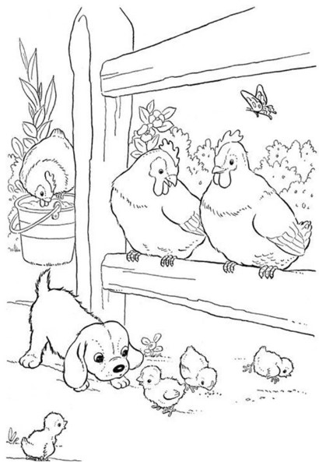
NIMBIN SHOW 2024
COLOURING COMPETITION
NAME……………………………………………………….……………AGE ………..
SCHOOL……………………………………………………………………………………..

